Problem Query in Sql
- Total Revenue:
select sum(total_price) as Total_revenue from pizza_sales;
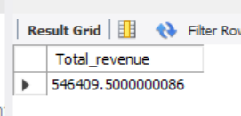
- Average Order Value:

select sum(total_price) / count(distinct order_id) as average_order_value from pizza_sales;

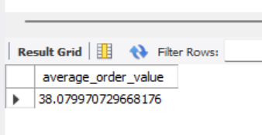

- Total Sold Pizza:
select sum(quantity) as Total_sold_pizza from pizza_sales;
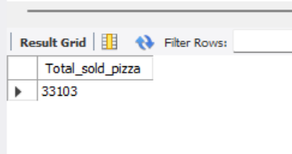
- Total Orders:

select count(distinct order_id) as Total_orders from pizza_sales;

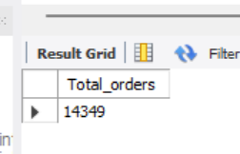

- Average Pizzas Per Order:

select sum(quantity) / count(distinct order_id) from pizza_sales;
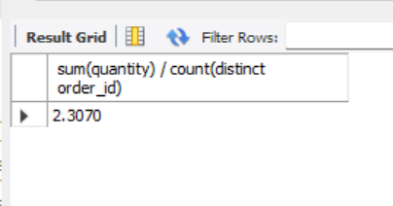

- Sales by pizza Category:

select pizza_category,sum(total_price) * 100 / (select sum(total_price) from pizza_sales)
from pizza_sales group by pizza_category

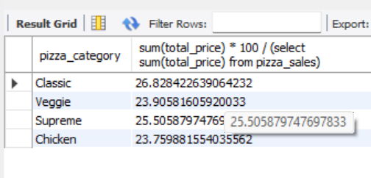

- Find trend by day in order
UPDATE `pizza_dbs`.`pizza_sales`
SET `order_date` = DATE_FORMAT(STR_TO_DATE(`order_date`, '%d-%m-%Y'), '%Y-%m-%d')
WHERE `order_date` IS NOT NULL;

SELECT DAYNAME(order_date) AS weekday, COUNT(DISTINCT order_id) AS total_orders
FROM pizza_sales GROUP BY DAYNAME(order_date);

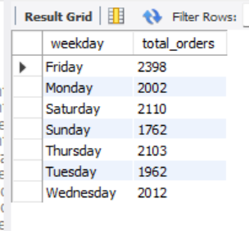

- Total sales percentage by category
select pizza_category,sum(total_price) as total_sales,sum(total_price)*100/(select sum(total_price) from pizza_sales) as percentage from pizza_sales group by pizza_category;

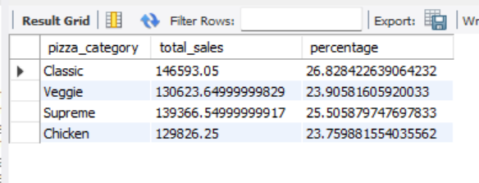

- Total Sales percentage by pizza size
select pizza_size,round(sum(total_price)) as total_sales,sum(total_price)*100/(select sum(total_price) from pizza_sales) as percentage from pizza_sales group by pizza_size;

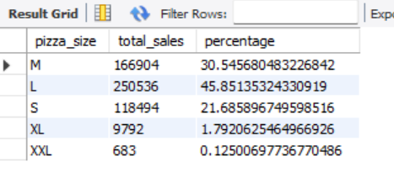

- Total Sales by pizza_names

select pizza_name,sum(total_price) as revenue from pizza_sales group by pizza_name order by revenue desc;

